Prabhu Manoharan

### React Native

### Universal Windows Platform Environment Setup

# ­­­­­­­­­­­­­­­Onetime Setup

1. Download and Install Visual Studio 2017

<https://visualstudio.microsoft.com/downloads/>

1. Download and Install Visual Studio Code

<https://code.visualstudio.com/docs/?dv=win>

1. Download and Install NodeJS

<https://www.npmjs.com/get-npm>

1. Install React Native CLI

npm i -g react-native-cli

1. Install TypeScript

npm i -g typescript

1. Create your project

react-native init --version="0.55.0-rc.0" MyApp --template typescript && node MyApp/setup.js

1. Change project directory MyApp

cd MyApp

1. Install the React Native Windows CLI Plugin

npm i --save-dev rnpm-plugin-windows

1. Run the Windows initialization command

react-native windows --windowsVersion 0.55.0-rc.0

1. Open project MyApp.sln file in Visual Studio
2. Follow the prompts to install the Windows 10 SDK v. 10.0.14393.0
3. If prompted, select Developer Mode in the Settings window under "Use developer features" and approve the Certificate Installation request. Enable "Developer mode" to allow the custom application to run
4. Install windows build tools (run in Windows Power Shell)

npm i -g --production windows-build-tools

1. Run your application

react-native run-windows

1. Prompt Windows PowerShell Installing Certificate: Enter Y to install
2. Prompt window: Allow Access to windows firewall

# Regular Basis UWP Project Creation

1. Open a command prompt
2. Create your project

react-native init --version="0.55.0-rc.0" MyApp --template typescript && node MyApp/setup.js

1. Change project directory MyApp

cd MyApp

1. Install the React Native Windows Plugin

npm i --save-dev rnpm-plugin-windows

1. Run the Windows initialization command

react-native windows --windowsVersion 0.55.0-rc.0

1. Installing TypeScript library, linter and some other required libraries

npm install typescript tslint react-native-typescript-transformer tslint-react-recommended --save-dev

1. Install typings for React and React Native libraries

npm install @types/react @types/react-native --save-dev

1. Run your application

react-native run-windows

1. Prompt Windows PowerShell Installing Certificate: Enter Y to install

# Debugging code with Chrome

Press Ctrl+R to reload, Chrome browser will load for debugging

(or)

Shift+F10 or shake for dev menu, then choose Remote JS Debugging

# Regular Basis WPF Project Creation

1. Open a command prompt
2. Create your project

react-native init --version="0.55.0-rc.0" MyWPFApp --template typescript && node MyWPFApp/setup.js

1. Change project directory MyApp

cd MyApp

1. Install the React Native Windows Plugins

npm i --save-dev rnpm-plugin-windows

npm i --save-dev rnpm-plugin-wpf

1. Run the Windows initialization command

react-native wpf --windowsVersion 0.55.0-rc.0

1. Installing TypeScript library, linter and some other required libraries

npm install typescript tslint react-native-typescript-transformer tslint-react-recommended --save-dev

1. Install typings for React and React Native libraries

npm install @types/react @types/react-native --save-dev

1. Start react-native   
   react-native start
2. Clean, Build & Run the solution in visual studio

# UWP App Deployment

1. Choose **ReleaseBundle** instead of Release

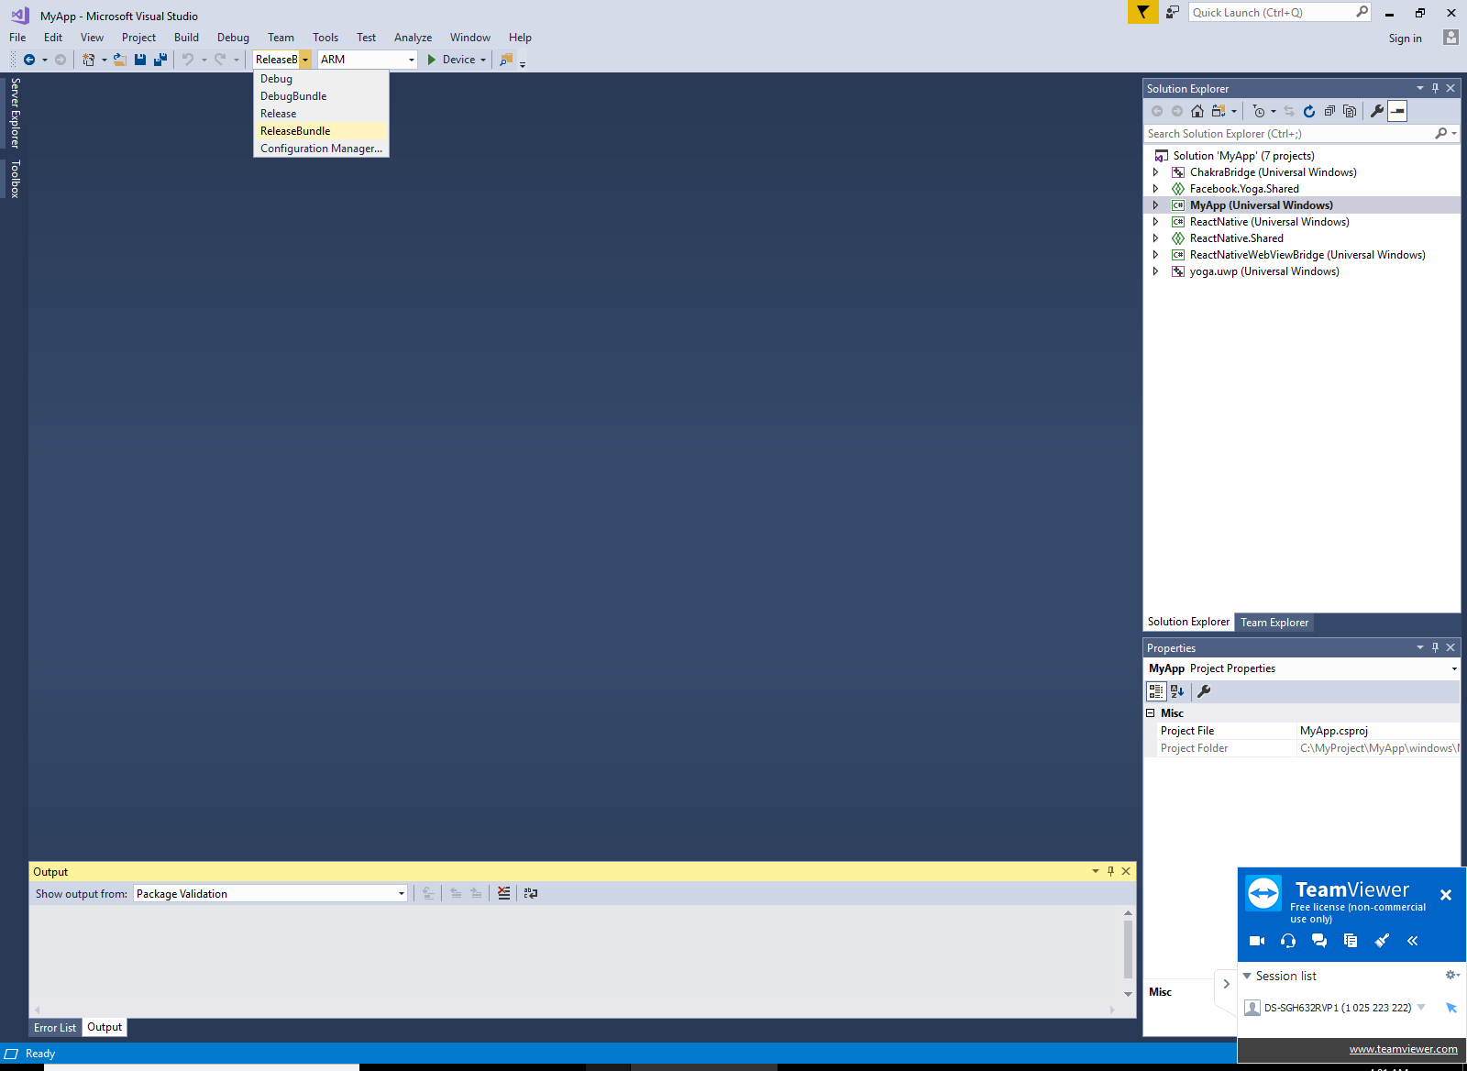

1. Go Project Properties

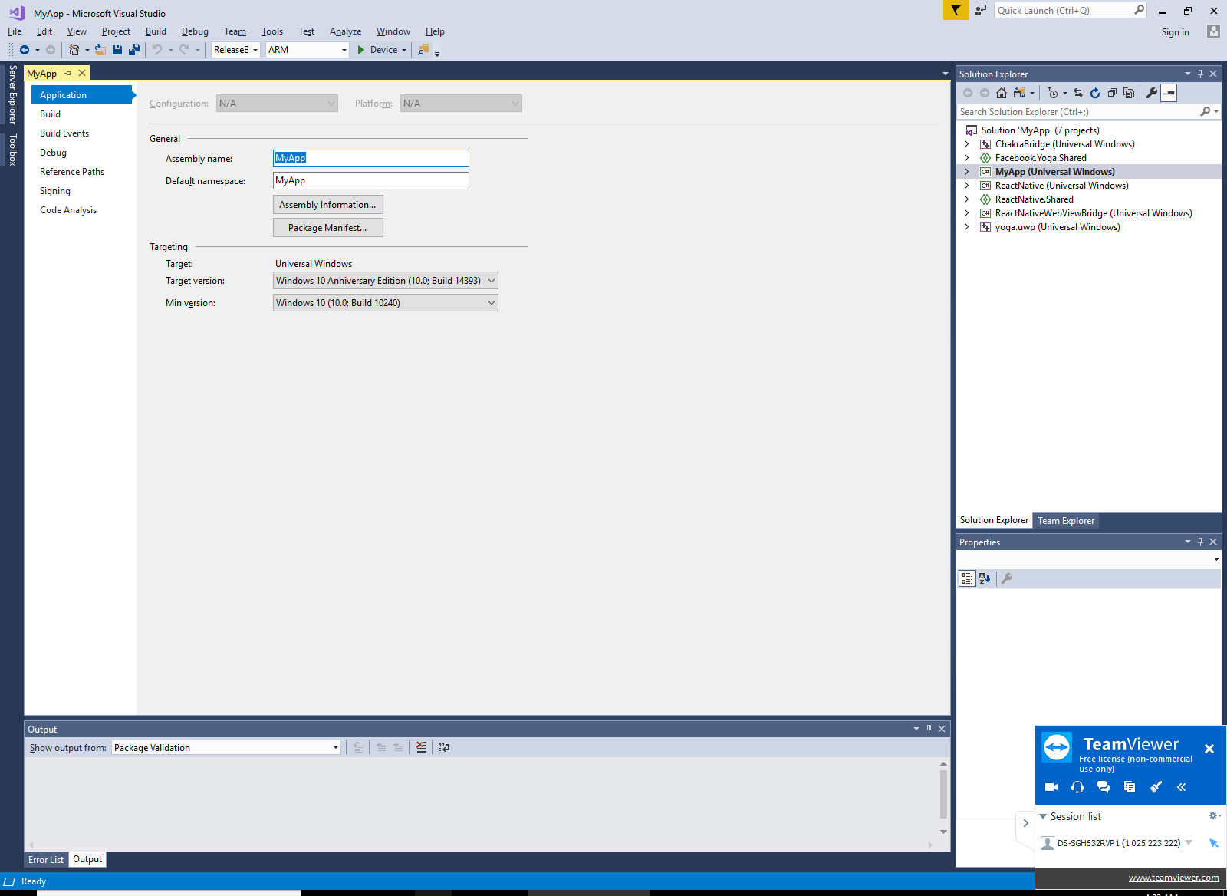

1. Click **Package Manifest**, Select **Visual Assets**

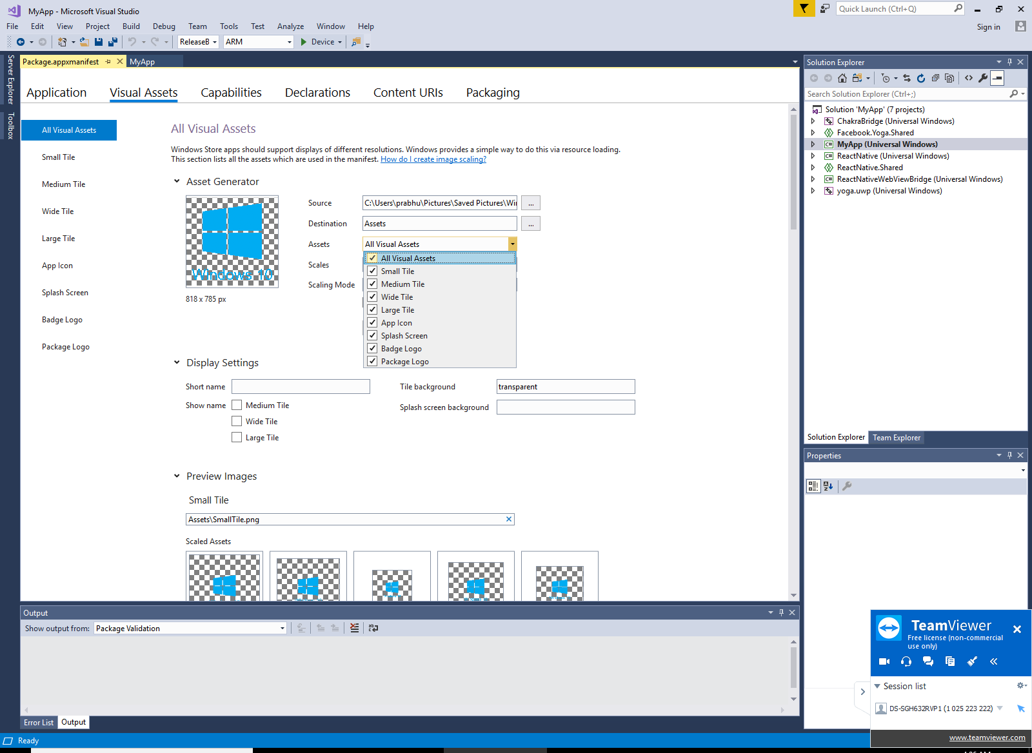

1. In **Source** file upload box choose any image.

(The app must contain localized resources for all languages it supports. Image files that are created by visual studio template for the tiles and store logo must be replaced)

1. In **Assets** dropdown choose **All Visual Assets** and Click **Generate** button
2. Save All
3. Clean, Rebuild solution
4. Then Right Click on the project - > select **Store** - > select **Create App Package**
5. That’s it.
6. Open the app export folder C:\MyProject\MyApp\windows\MyApp\AppPackages\MyApp_1.0.5.0_ReleaseBundle_Test
7. Right-click on the Add-AppDevPackage.ps1 file, then choose Run with PowerShell and follow the prompts.
8. Click the Start button and then type the name of your app to launch it.

# WPF Deployment

1. Choose **Release** mode
2. If getting error (Please update all the nuget packages up to date)
3. If getting error again (do the steps, check the stackflow url)

<https://stackoverflow.com/questions/22909506/this-project-references-nuget-packages-that-are-missing-on-this-computer?rq=1>

1. Then Right Click on the project - > select **Publish** - > Next -> Finish
2. Opened the output folder, you can install the app using setup file.